|  |  |
| --- | --- |
| **Open Issue** | **Issue description** |
| - | - |
|  |  |

Table of Contents

1 DOCUMENT INTRODUCTION 3

1.1 Purpose 3

1.2 CDP2 Overall Connectivity architecture 3

1.3 Scope 3

1.4 References 3

1.5 Terminology & Abbreviations 3

2 Test Method 5

3 Sampling Method 5

4 Test Set-up 5

5 Test Conditions 5

6 Test Cases 6

6.1 Manual Test Cases 6

6.2 Automated Test Cases 6

7 Test Instructions 6

8 Revision History 6

9 Approval 6

# DOCUMENT INTRODUCTION

## Purpose

This document describes the test cases (test scenarios) to be used for the verification of BlueLib, demonstrating it meets the requirements, see ref. [SwRS], of BlueLib.

## CDP2 Overall Connectivity architecture

Below picture shows the overall connectivity architecture and components. The components inside the blue box are described in this document.

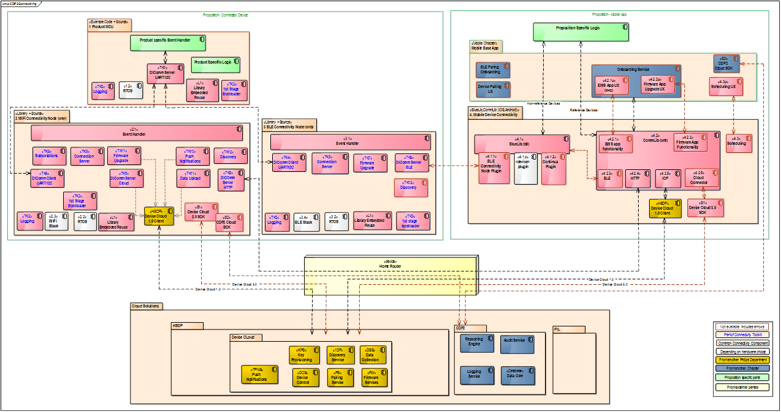

Figure 1 - CDP2 Overall Connectivity architecture

## Scope

This document applies to BlueLib (Android and iOS), to be used in connected digital propositions.

## References

| **Reference** | **Identification** | **Title / additional remarks** |
| --- | --- | --- |
| [SwRS] | BLL000001 | Requirements, BlueLib |
| [DiComm] | JohSun-20160115-04V01 | SwIS DIComm Protocol |
| [SwTM] | BLL000007 | RequirementsTraceability Matrix, BlueLib |
| [TPCml] | CML000003 | Test Protocol CommLib |

## Terminology & Abbreviations

| **Terminology & Abbreviations** | **Description/Definition** |
| --- | --- |
| BLE | Bluetooth Low Energy |
| DiComm | Digital Interface Communication Protocol, see ref [DiComm] |
| Gherkin | Gherkin is a Business Readable, Domain Specific Language that lets you describe software’s behavior without detailing how that behavior is implemented. It is used to specify test scenarios that can be interpreted by tools like: cucumber and SpecFlow. Reference: The Cucumber Book (ISBN 978-1-93435-680-7) |
| TC | Test Case |

# Test Method

The test scenarios are written in the [Gherkin] design specification language. The [Gherkin] design specification language provides human-readable scenarios and steps (Given, When, Then) that could be executed either manually or automatically. The test scenarios shall verify that the requirements are met and shall be understandable by non-technical business owners.

A test scenario is part of a [Gherkin] feature file.  
A feature file contains one or more scenarios.

A requirement Id specified in the requirements document [SwRS] is tested on its key elements by one or more scenarios.

# Sampling Method

Not applicable. For the software tests no sampling method is applied.

# Test Set-up

For the manual tests, the required software tools and settings are contained in the manual [Gherkin] test scenarios themselves.

# Test Conditions

The test conditions are fully contained inside the [Gherkin] test scenarios themselves.

# Test Cases

No test cases have been defined for BlueLib. BlueLib is implicitly verified by BLE test cases defined for CommLib [TPCml].

The requirements traceability matrix [SwTM] shows what requirement is verified by what test case (scenario).

## Manual Test Cases

|  |  |  |
| --- | --- | --- |
| Test Case ID | Test Case Title | Steps |

## Automated Test Cases

Automated test cases for BlueLib have not been defined.

The feature files are listed in the table below:

|  |  |
| --- | --- |
| Feature Filename | Description |

The table below shows all the test cases (scenarios) to verify the requirements of BlueLib:

|  |  |
| --- | --- |
| Test Case ID | Test Case Title |

# Test Instructions

Not applicable. The test instructions are part of the steps of the test scenarios themselves.

# Revision History

| **Version** | **Date** | **Author** | **Description of Change** | **Reason for Change** |
| --- | --- | --- | --- | --- |
| 0.1 | 2017-May-01 | Gerard Arts | Initial draft | Creation |
| 1.0 | 2017-May-03 | Gerard Arts | Approver updated | Ready for Review |
| 1.1 | 2017-May-05 | Gerard Arts | Review remarks implemented | Review remarks implemented |
| 2.0 | 2017-May-10 | Gerard Arts | Version changed | For approval |

# Approval

| **Name** | **Role / Function** | **Date** (YYYY-MON-DD) | **Signature** |
| --- | --- | --- | --- |
| Matthijs Piek | Product Owner |  |  |